Data 1

• Null hypothesis: Salt has no effect on plant biomass growth; Alternative: Salt has effect on biomass growth

• Choice of ANOVA model: Two-way ANOVA with salt as fixed effect and blocks as random effect. The assumption is that the block variable, i.e. the geographical location, is chosen at random, and only in this way our inference can extend to other geographical places.

• Checked the assumptions of statistical test:

Used tapply shapiro.test to test the assumption of normality;

Used bartlett.test to test the assumption of homogeneity of variance;

From the description we assumed the independence of each observation.

• Results of your statistical test: There are significant difference between means of biomass on different salt level. This means the effect of salt on biomass is significant.

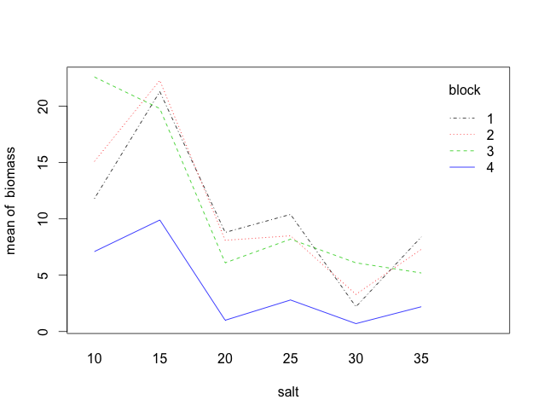

• An interpretation of any necessary post-hoc tests

By means of Tukey. The level by alpha default is 0.05. There are significant differences in 25-10 30-10 35-10 20-15 25-15 30-15 35-15

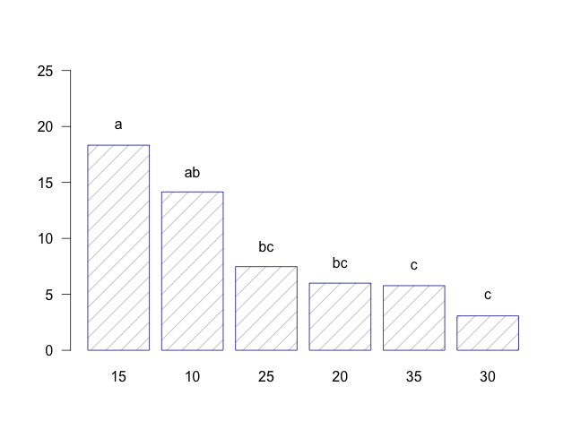

• An interpretation of diagnostic figures

Since plotting does not work with random variable, I used mod0 <- aov(biomass ~ salt + block, data=biod)

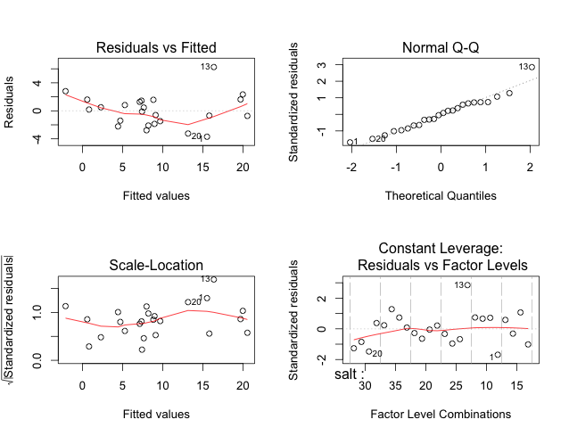

Data 2

•H0: no difference of thickness among different treatment; no interaction between doses and supplements;

Ha: there is difference of thickness among different treatment; there is interaction between doses and supplements.

• Choice of ANOVA model: Two-way ANOVA with doses and supplements both as fixed effect.

• Checked the assumptions of statistical test:

Used tapply shapiro.test to test the assumption of normality;

Used bartlett.test to test the assumption of homogeneity of variance;

From the description we assumed the independence of each observation.

• Results of your statistical test: Effect of supplement on thickness is significant, effect of levels of doses is also significant. There is interaction between doses and supplements.

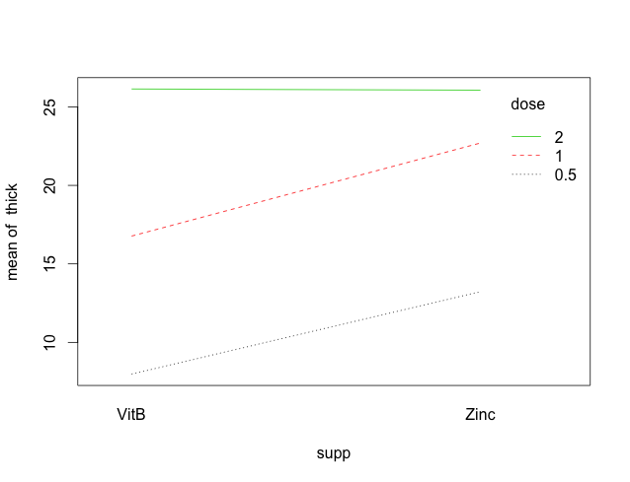

• An interpretation of any necessary post-hoc tests

There is significant difference in the effects of 1 to 0.5, 1 to 0.5 and 2 to 1.

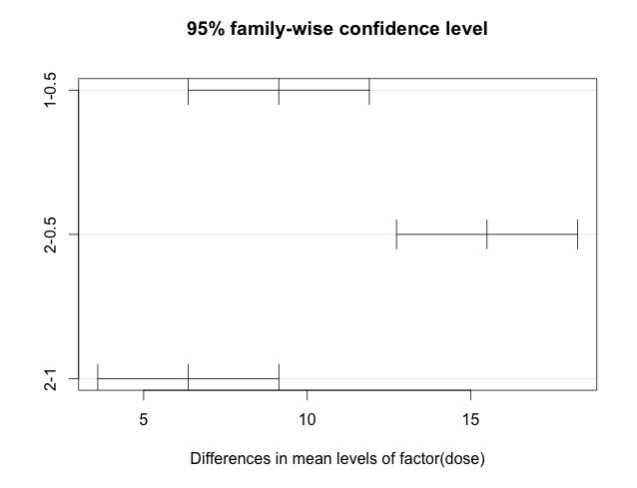

• An interpretation of diagnostic figures

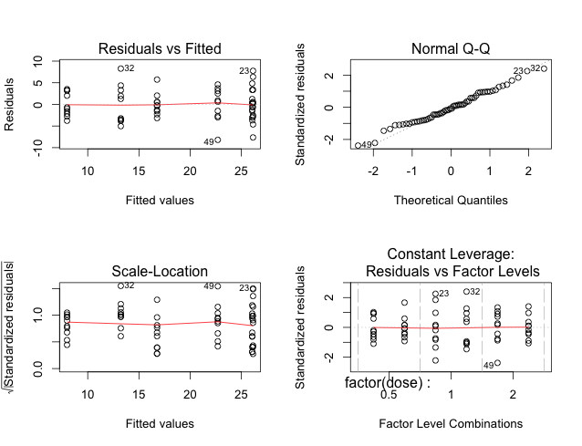

Appendix. R Code

setwd("/Users/xuhong/Documents/Duke/Term 1 Courses/ENVIRON 710 Applied data analysis/Lab/Lab 8")

##################

# Data 1: biomass

##################

biod <- "obs salt block biomass

1 10 1 11.8

2 15 1 21.3

3 20 1 8.8

4 25 1 10.4

5 30 1 2.2

6 35 1 8.4

7 10 2 15.1

8 15 2 22.3

9 20 2 8.1

10 25 2 8.5

11 30 2 3.3

12 35 2 7.3

13 10 3 22.6

14 15 3 19.8

15 20 3 6.1

16 25 3 8.2

17 30 3 6.1

18 35 3 5.2

19 10 4 7.1

20 15 4 9.9

21 20 4 1.0

22 25 4 2.8

23 30 4 0.7

24 35 4 2.2"

biod <- read.delim(textConnection(biod), sep=" ")

biod$salt <- factor(biod$salt)

biod$block <- factor(biod$block)

par(mfrow=c(1,1))

# check the normal assumption

with(biod, boxplot(biomass~salt))

with(biod, tapply(biomass, salt, shapiro.test))

with(biod, tapply(biomass, block, shapiro.test))

# check the homogeneity of variance

bartlett.test(biomass~salt, data=biod)

bartlett.test(biomass~salt*block, data=biod)

#

mod0 <- aov(biomass ~ salt + block, data=biod)

mod1 <- aov(biomass ~ salt + Error(block), data=biod)

summary(mod1)

with(biod, interaction.plot(salt, block, biomass, col = c(1,2,3,4)))

# Post hoc test

plot(TukeyHSD(mod0, 'salt'))

require("agricolae")

out <- with(biod, HSD.test(biomass, salt, DFerror = 5,

MSerror = 7.69))

bar.group(out$groups, density=6, ylim=c(0,25),

border="darkblue", las=1)

with(biod, tapply(biomass, list(salt), mean))

# Diagnostic plots

par(mfrow=c(2,2))

plot(mod0)

##################

# Data 2: thickness of scale

##################

thk <- read.csv("ScaleThickness.csv", sep=",")

par(mfrow=c(1,1))

# check the normal assumption

with(thk, boxplot(thick~supp+dose))

with(thk, tapply(thick, supp, shapiro.test))

with(thk, tapply(thick, dose, shapiro.test))

# check the homogeneity of variance

bartlett.test(thick~supp, data=thk)

bartlett.test(thick~dose, data=thk)

#

mod2 <- aov(thick ~ factor(dose)*supp, data=thk)

summary(mod2)

with(thk, interaction.plot(supp, dose, thick, col = c(1,2,3)))

# Post hoc test

plot(TukeyHSD(mod2, factor('dose')))

plot(TukeyHSD(mod2, 'supp'))

# Diagonistic plots

par(mfrow=c(2,2))

plot(mod2)